Joel Rivera

Et-574 F2F4L

Lab 10

11/13/2024

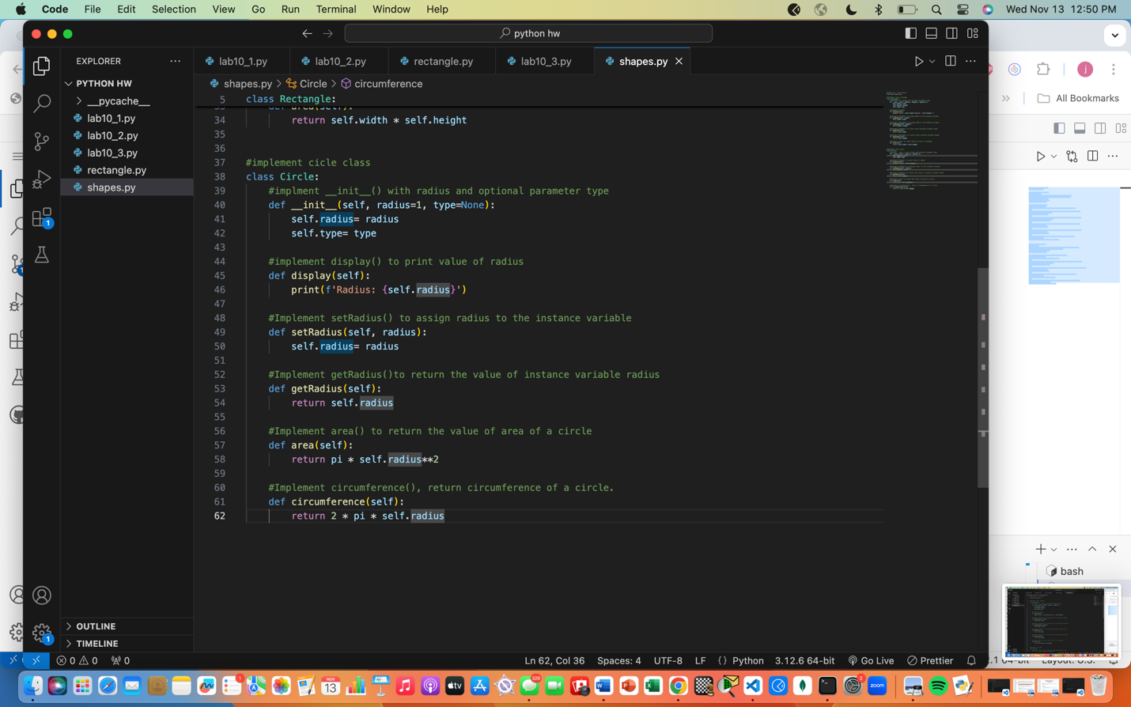

4. I faced more than two challenges in this week’s lab lol but the first main challenge was in question one; within the display method I was originally passing width and not getting the desired output but an error. I realized that I needed to use self since it refers to the current instance of self.width. when I made the change, I got the desired output. The second challenge came from the second question; when I was trying to define the setWidth() method I had originally wrote width= self.width and the code wasn’t working but when I switch it around to then assign the value of width to the instance variable self.width, I got the desired output.